Data Analytics

Lab Assignment I

Vishal Ambavade (16CS02)

data2011.r

Vishal

Sun Feb 17 11:02:32 2019

library(dplyr)

##   
## Attaching package: 'dplyr'

## The following objects are masked from 'package:stats':  
##   
## filter, lag

## The following objects are masked from 'package:base':  
##   
## intersect, setdiff, setequal, union

library(ggplot2)  
  
data2011 = read.csv("D:\\Vishal\\III year\\Data Analytics\\Assignment I\\CRS-2011.csv",  
 nrows = 41)  
  
data2011 <- Filter(function(x)!all(is.na(x)), data2011)  
  
summary(data2011)

## Year Live_births Still_births Deaths   
## Min. :1971 Min. : 406812 Min. : 2373 Min. : 87556   
## 1st Qu.:1981 1st Qu.: 466387 1st Qu.: 4557 1st Qu.:171857   
## Median :1991 Median : 792291 Median : 5472 Median :224115   
## Mean :1991 Mean : 755063 Mean : 6227 Mean :256804   
## 3rd Qu.:2001 3rd Qu.:1009716 3rd Qu.: 6940 3rd Qu.:355662   
## Max. :2011 Max. :1108562 Max. :13312 Max. :387604   
## Vital_Births Vital_Deaths Percentage_Births Percentage_Deaths  
## Min. :10.51 Min. :2.410 Min. :36.10 Min. :25.10   
## 1st Qu.:13.65 1st Qu.:4.590 1st Qu.:47.40 1st Qu.:45.20   
## Median :17.68 Median :6.000 Median :65.60 Median :58.40   
## Mean :16.56 Mean :5.572 Mean :68.22 Mean :66.24   
## 3rd Qu.:18.95 3rd Qu.:6.640 3rd Qu.:89.34 3rd Qu.:90.71   
## Max. :21.60 Max. :7.160 Max. :99.47 Max. :98.87

head(data2011)

## Year Live_births Still_births Deaths Vital_Births Vital_Deaths  
## 1 1971 469226 9966 176160 16.00 6.00  
## 2 1972 484616 13312 179593 16.10 6.00  
## 3 1973 463130 11970 193725 14.94 6.24  
## 4 1974 435353 10612 166102 13.74 5.24  
## 5 1975 453444 10689 171857 13.97 5.29  
## 6 1976 454851 10713 176061 13.68 5.30  
## Percentage_Births Percentage_Deaths  
## 1 50.5 40.6  
## 2 51.1 47.2  
## 3 51.7 50.3  
## 4 49.1 48.1  
## 5 50.4 48.1  
## 6 46.4 45.3

sd(data2011$Live_births)

## [1] 264177.7

cor(data2011$Live_births, data2011$Deaths)

## [1] 0.9518286

tail(data2011)

## Year Live_births Still_births Deaths Vital_Births Vital_Deaths  
## 36 2006 1046531 5091 387604 18.95 7.02  
## 37 2007 1046424 5526 381890 18.95 6.92  
## 38 2008 1082450 5069 372062 19.30 6.63  
## 39 2009 1076383 5729 373290 19.05 6.61  
## 40 2010 1071518 6587 381743 18.29 6.51  
## 41 2011 1108562 6940 384745 18.72 6.50  
## Percentage_Births Percentage_Deaths  
## 36 94.28 98.87  
## 37 95.23 94.79  
## 38 97.47 89.59  
## 39 97.69 91.81  
## 40 95.26 91.69  
## 41 99.47 91.55

ggplot(data2011, aes(x = Year, y = Live_births)) +  
 geom_line() +  
 labs(title = "Live births by year")

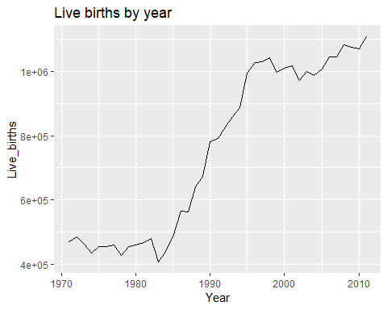

ggplot(data2011, aes(fill = Deaths, x = Year, y = Live_births)) +  
 geom_bar(stat = "identity") +  
 labs(title = "Live births and deaths per year")

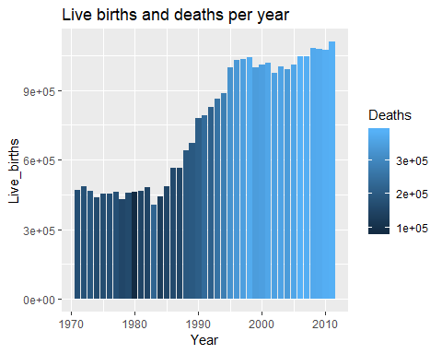

ggplot(data2011, aes(fill = Percentage_Births, y = Percentage_Births,   
 Percentage_Deaths, x=Year)) +   
 geom_bar(position="dodge", stat="identity") +  
 labs(title = "Percentage births per year")

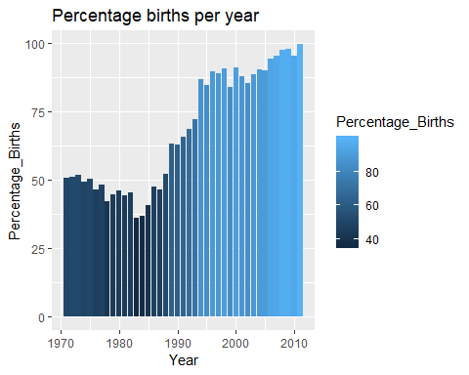

ggplot(data2011, aes(Year, y = Still_births, Deaths)) +  
 geom_boxplot() +  
 labs(title = "Still births per year")

## Warning: Continuous x aesthetic -- did you forget aes(group=...)?

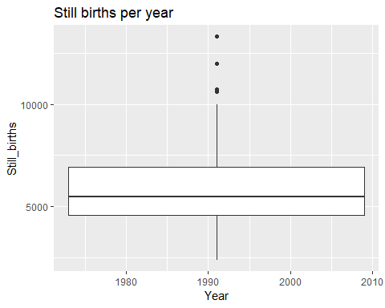

ggplot(data2011, aes(Year)) +   
 geom_line(aes(y = Deaths, colour = "Deaths")) +   
 geom_line(aes(y = Live_births, colour = "Live births")) +  
 labs(title = "Comparison between Live births and deaths by year")

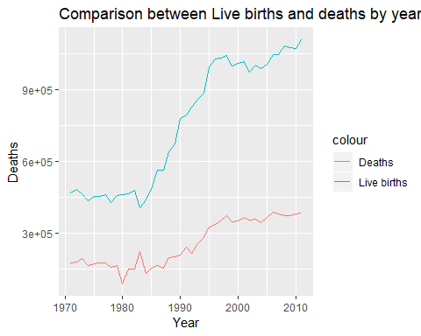

ggplot(data2011, aes(x = Year, y = Deaths)) +  
 geom_point()

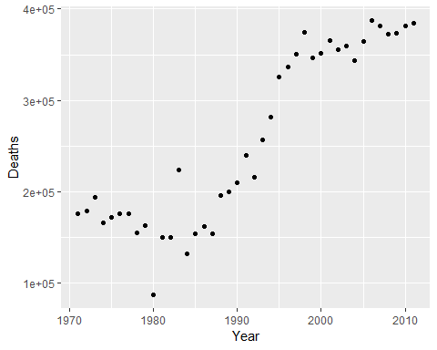

data2011_2 <- read.csv("D:\\Vishal\\III year\\Data Analytics\\Assignment I\\CRS-2011.csv", skip=44, nrows=30,  
 header = TRUE)  
  
data2011_2 <- Filter(function(x)!all(is.na(x)), data2011_2)  
#head(data2011_2)  
  
tb2 <- data2011_2 %>%  
 filter(District != "STATE")  
  
ggplot(tb2, aes(x = District, y = Births_Registered)) +  
 geom_col() +  
 theme(axis.text.x = element_text(angle = 60, hjust = 1)) +  
 labs(title = "Births registered by district")

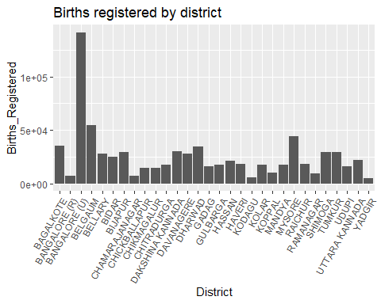

ggplot(tb2, aes(x = District, y = Birth_Rate)) +  
 geom_col() +  
 theme(axis.text.x = element_text(angle = 60, hjust = 1)) +  
 labs(title = "Districtwise birth rate")

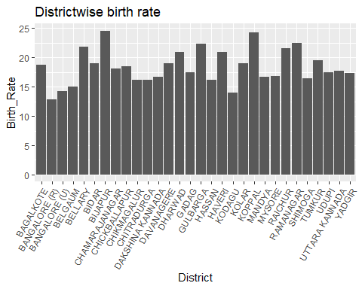

popTable <- read.csv("D:\\Vishal\\III year\\Data Analytics\\Assignment I\\CRS-2011.csv", skip=158, nrows=30,  
 header = TRUE)  
popTable <- Filter(function(x)!all(is.na(x)), popTable)  
  
summary(popTable)

## Sl.N.o Districts Actual_population  
## Min. : 1.00 Bagalkote : 1 Min. : 473659   
## 1st Qu.: 8.25 Bangalore(R): 1 1st Qu.: 876248   
## Median :15.50 Bangalore(U): 1 Median :1144972   
## Mean :15.50 Belgaum : 1 Mean :1251751   
## 3rd Qu.:22.75 Bellary : 1 3rd Qu.:1427823   
## Max. :30.00 Bidar : 1 Max. :3567739   
## (Other) :24   
## Adjusted_for_incomplete_returns No_of_Registration_Units  
## Min. : 468192 Min. : 255.0   
## 1st Qu.: 858540 1st Qu.: 543.8   
## Median :1098805 Median : 790.5   
## Mean :1190842 Mean : 931.7   
## 3rd Qu.:1328014 3rd Qu.:1201.5   
## Max. :3540968 Max. :2719.0   
##   
## No_of_Monthly_Returns_due No_of_Monthly_Returns_not_received  
## Min. : 3060 Min. : 0.0   
## 1st Qu.: 6525 1st Qu.: 0.0   
## Median : 9486 Median : 35.0   
## Mean :11180 Mean : 538.4   
## 3rd Qu.:14418 3rd Qu.: 653.2   
## Max. :32628 Max. :3902.0   
##   
## Estimated_Mid_year_Population_final Incomplete_returns  
## Min. : 473675 Min. : 468207   
## 1st Qu.: 878519 1st Qu.: 859095   
## Median :1148899 Median :1100348   
## Mean :1254931 Mean :1193798   
## 3rd Qu.:1432750 3rd Qu.:1330908   
## Max. :3580666 Max. :3553798   
##

head(popTable)

## Sl.N.o Districts Actual_population Adjusted_for_incomplete_returns  
## 1 1 Bagalkote 1292036 1277161  
## 2 2 Bangalore(R) 719564 718234  
## 3 3 Bangalore(U) 868971 693938  
## 4 4 Belgaum 3567739 3540968  
## 5 5 Bellary 1613038 1586607  
## 6 6 Bidar 1276647 1161523  
## No_of_Registration_Units No_of_Monthly_Returns_due  
## 1 608 7296  
## 2 947 11364  
## 3 573 6876  
## 4 1155 13860  
## 5 534 6408  
## 6 621 7452  
## No_of_Monthly_Returns_not_received Estimated_Mid_year_Population_final  
## 1 84 1296203  
## 2 21 721695  
## 3 1385 872221  
## 4 104 3580666  
## 5 105 1623871  
## 6 672 1280834  
## Incomplete_returns  
## 1 1281279  
## 2 720361  
## 3 696533  
## 4 3553798  
## 5 1597262  
## 6 1165332

ggplot(popTable, aes(x = Districts, y = Actual_population)) +  
 geom_bar(stat = "identity") +  
 coord_polar(theta = "y") +  
 labs(title = "Districtwise population(Actual)")

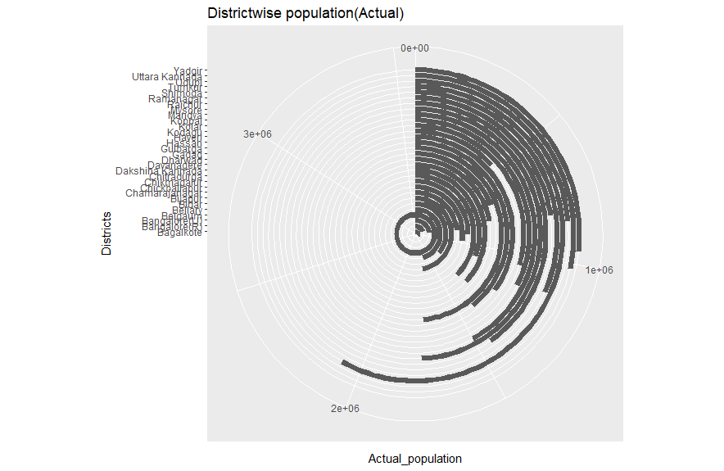

ggplot(popTable, aes(x = Districts, y = Incomplete_returns)) +  
 geom_col() +  
 theme(axis.text.x = element_text(angle = 60, hjust = 1)) +  
 labs(title = "Incomplete returns per district")

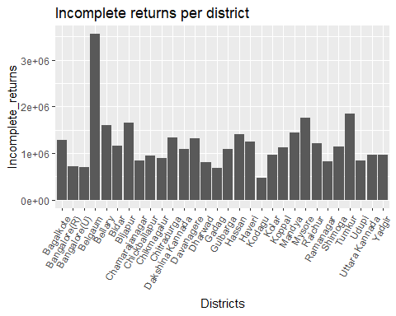

liveBirthsReg <- read.csv("D:\\Vishal\\III year\\Data Analytics\\Assignment I\\CRS-2011.csv", skip=710, nrows=30,  
 header = TRUE)  
  
liveBirthsReg <- Filter(function(x)!all(is.na(x)), liveBirthsReg)  
  
tail(liveBirthsReg)

## X District RuralWithinPrescribedTimeLimitMale  
## 25 25 RAMANAGAR 1859  
## 26 26 SHIMOGA 1810  
## 27 27 TUMKUR 5493  
## 28 28 UDUPI 1698  
## 29 29 UTTARA KANNADA 1983  
## 30 30 YADGIR 11384  
## RuralWithinPrescribedTimeLimitFemale RuralWithin30Male  
## 25 1861 10  
## 26 1875 25  
## 27 5447 108  
## 28 1359 11  
## 29 1785 23  
## 30 14936 504  
## RuralWithin30Female RuralAfter30Male RuralAfter30Female RuralAfter1Male  
## 25 20 18 21 28  
## 26 37 30 40 185  
## 27 115 69 91 163  
## 28 9 22 21 229  
## 29 10 46 49 237  
## 30 631 163 231 82  
## RuralAfter1Female UrbanWithinPrescribedTimeLimitMale  
## 25 18 4313  
## 26 120 13794  
## 27 93 12988  
## 28 116 7738  
## 29 142 10371  
## 30 30 1130  
## UrbanWithPrescribedTimeLimitFemale UrbanWithin30Male  
## 25 4144 337  
## 26 12864 674  
## 27 12445 598  
## 28 7178 598  
## 29 10034 417  
## 30 1293 259  
## UrbanWithin30Female UrbanAfter30Male UrbanAfter30Female UrbanAfter1Male  
## 25 310 174 237 106  
## 26 631 482 529 293  
## 27 657 1213 1193 239  
## 28 558 182 133 47  
## 29 415 290 275 218  
## 30 387 605 887 111  
## UrbanAfter30Female.1  
## 25 91  
## 26 166  
## 27 163  
## 28 29  
## 29 130  
## 30 44

summary(liveBirthsReg)

## X District RuralWithinPrescribedTimeLimitMale  
## Min. : 1.00 BAGALKOTE : 1 Min. : 771   
## 1st Qu.: 8.25 BANGALORE [R]: 1 1st Qu.: 1870   
## Median :15.50 BANGALORE [U]: 1 Median : 3058   
## Mean :15.50 BELGAUM : 1 Mean : 5150   
## 3rd Qu.:22.75 BELLARY : 1 3rd Qu.: 6091   
## Max. :30.00 BIDAR : 1 Max. :20531   
## (Other) :24   
## RuralWithinPrescribedTimeLimitFemale RuralWithin30Male  
## Min. : 808 Min. : 10.0   
## 1st Qu.: 1864 1st Qu.: 32.5   
## Median : 2996 Median :101.5   
## Mean : 5512 Mean :163.1   
## 3rd Qu.: 6494 3rd Qu.:198.0   
## Max. :19733 Max. :870.0   
##   
## RuralWithin30Female RuralAfter30Male RuralAfter30Female RuralAfter1Male  
## Min. : 9.00 Min. : 18.00 Min. : 18.00 Min. : 17.0   
## 1st Qu.: 39.75 1st Qu.: 36.25 1st Qu.: 38.00 1st Qu.: 53.5   
## Median :110.00 Median : 47.00 Median : 61.00 Median : 99.0   
## Mean :181.57 Mean : 69.37 Mean : 91.97 Mean :110.7   
## 3rd Qu.:243.25 3rd Qu.: 97.25 3rd Qu.:139.75 3rd Qu.:149.8   
## Max. :933.00 Max. :199.00 Max. :280.00 Max. :305.0   
##   
## RuralAfter1Female UrbanWithinPrescribedTimeLimitMale  
## Min. : 10.00 Min. : 1130   
## 1st Qu.: 32.50 1st Qu.: 4920   
## Median : 58.00 Median : 7336   
## Mean : 67.83 Mean :10547   
## 3rd Qu.: 92.25 3rd Qu.:12624   
## Max. :166.00 Max. :65676   
##   
## UrbanWithPrescribedTimeLimitFemale UrbanWithin30Male UrbanWithin30Female  
## Min. : 1293 Min. : 108 Min. : 117.0   
## 1st Qu.: 4593 1st Qu.: 532 1st Qu.: 557.2   
## Median : 7015 Median : 957 Median : 996.5   
## Mean : 9971 Mean :1142 Mean :1122.1   
## 3rd Qu.:11470 3rd Qu.:1483 3rd Qu.:1504.0   
## Max. :61763 Max. :4489 Max. :4084.0   
##   
## UrbanAfter30Male UrbanAfter30Female UrbanAfter1Male UrbanAfter30Female.1  
## Min. : 23.0 Min. : 21.0 Min. : 20.0 Min. : 12.0   
## 1st Qu.: 493.2 1st Qu.: 526.8 1st Qu.: 88.5 1st Qu.: 49.0   
## Median : 972.0 Median : 890.5 Median : 128.0 Median : 89.0   
## Mean :1175.0 Mean :1181.6 Mean : 275.4 Mean : 191.6   
## 3rd Qu.:1556.5 3rd Qu.:1761.2 3rd Qu.: 263.0 3rd Qu.: 141.2   
## Max. :3731.0 Max. :3480.0 Max. :3601.0 Max. :2903.0   
##

cor(liveBirthsReg$RuralWithinPrescribedTimeLimitMale, liveBirthsReg$RuralWithinPrescribedTimeLimitFemale)

## [1] 0.9864787

ggplot(liveBirthsReg, aes(x = District, group = 1)) +   
 theme(axis.text.x = element_text(angle = 60, hjust = 1)) +  
 geom_point(aes(x= District, y = RuralWithinPrescribedTimeLimitMale)) +  
 geom_point(aes(y = UrbanWithinPrescribedTimeLimitMale)) +  
 geom_line(aes(y = RuralWithinPrescribedTimeLimitMale, colour = "Male reg. in prescribed Time limit(Rural)")) +   
 geom_line(aes(y = UrbanWithinPrescribedTimeLimitMale, colour = "Male reg. in prescribed Time limit(Urban)")) +  
 labs(title = "Comparison between on time reg(male) in Rural and Urban areas")

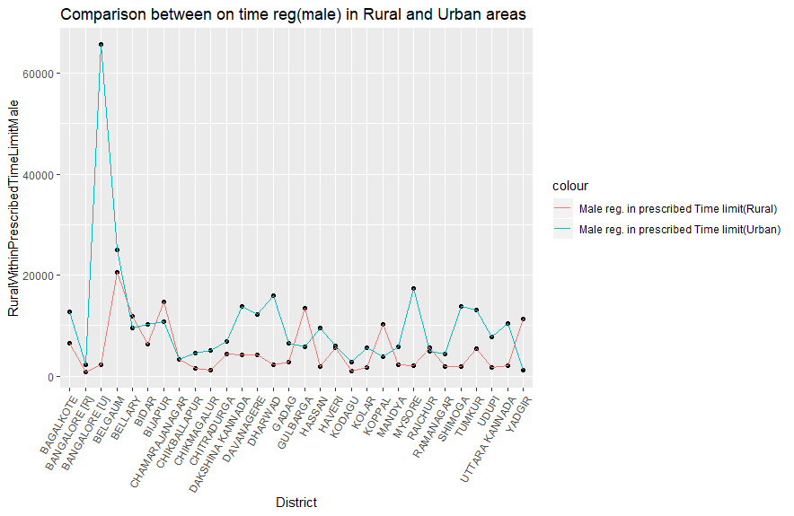

data2014.r

Vishal

Sun Feb 17 11:00:33 2019

library(dplyr)

##   
## Attaching package: 'dplyr'

## The following objects are masked from 'package:stats':  
##   
## filter, lag

## The following objects are masked from 'package:base':  
##   
## intersect, setdiff, setequal, union

library(ggplot2)  
library(reshape2)  
library(gridExtra)

##   
## Attaching package: 'gridExtra'

## The following object is masked from 'package:dplyr':  
##   
## combine

library(ggpubr)

## Loading required package: magrittr

data14 <- read.csv("D:\\Vishal\\III year\\Data Analytics\\Assignment I\\data14.csv", nrows = 60)  
  
  
tail(data14)

## District Sex Jan Feb Mar Apr May Jun Jul Aug Sep Oct  
## 55 UDUPI M 885 737 974 938 912 792 840 775 921 926  
## 56 UDUPI F 678 678 791 858 820 708 725 645 743 840  
## 57 UTTARA KANNADA M 1172 947 1333 1245 1146 1126 1105 1086 1149 1209  
## 58 UTTARA KANNADA F 1028 875 1209 1205 1006 1073 1106 936 1022 1096  
## 59 YADGIR M 1331 1106 1419 1525 1390 1386 1293 1303 1369 1408  
## 60 YADGIR F 1204 1123 1477 1475 1409 1446 1335 1313 1264 1424  
## Nov Dec X X.1  
## 55 885 897 NA NA  
## 56 748 842 NA NA  
## 57 984 1303 NA NA  
## 58 907 1320 NA NA  
## 59 1215 1256 NA NA  
## 60 1259 1230 NA NA

data14 <- Filter(function(x)!all(is.na(x)), data14)  
  
#df1 <- melt(data14, colnames(data14))  
  
#df1  
  
p1 <- ggplot(data14, aes(x = District, y = Jan)) +  
 geom_bar(aes(fill = Sex), stat="identity", position ="dodge") +   
 theme_bw()+   
 theme(axis.text.x = element_text(angle=-60, hjust=.1))  
  
p2 <- ggplot(data14, aes(x = District, y = Feb)) +  
 geom_bar(aes(fill = Sex), stat="identity", position ="dodge") +   
 theme_bw()+   
 theme(axis.text.x = element_text(angle=-60, hjust=.1))  
  
p3 <- ggplot(data14, aes(x = District, y = Mar)) +  
 geom_bar(aes(fill = Sex), stat="identity", position ="dodge") +   
 theme_bw()+   
 theme(axis.text.x = element_text(angle=-60, hjust=.1))  
  
p4 <- ggplot(data14, aes(x = District, y = Apr)) +  
 geom_bar(aes(fill = Sex), stat="identity", position ="dodge") +   
 theme_bw()+   
 theme(axis.text.x = element_text(angle=-60, hjust=.1))  
  
#ggplot(data14, aes(x=as.numeric(month), y=value, color=variable)) + geom_line()  
  
#grid.arrange(p1, p2, p3, p4)  
ggarrange(p1, p2, p3, p4,   
 labels = c("Jan", "Feb", "Mar", "Apr"),  
 ncol = 2, nrow = 2)

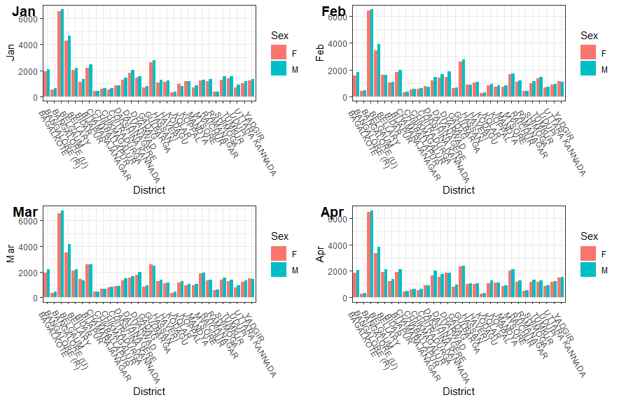

data14_2 <- read.csv("D:\\Vishal\\III year\\Data Analytics\\Assignment I\\data14.csv", skip = 65, header = TRUE, nrows = 27)  
tail(data14_2)

## Age.of.Mother X1 X2 X3 X4 X5 X6 X7 X8 X9 X10 X11 X12  
## 22 25 - 29 18003 36395 29812 4318 721 0 0 0 0 0 0 0  
## 23 30 - 34 2062 4516 3507 1385 713 193 44 0 0 0 0 0  
## 24 35 - 39 432 787 636 291 208 106 58 19 16 0 0 0  
## 25 40 - 44 54 69 40 27 18 19 11 13 10 1 0 0  
## 26 45 & above 8 8 11 18 10 2 3 2 2 2 0 0  
## 27 Age not Stated 0 0 0 0 0 0 0 0 0 0 0 0  
## X13...Above Not.Stated Area  
## 22 0 0 Rural  
## 23 0 0 Rural  
## 24 0 0 Rural  
## 25 0 0 Rural  
## 26 0 0 Rural  
## 27 0 0 Rural

data14_2_urban <- data14_2 %>%  
 filter(Area == "Urban")  
  
data14_2_rural <- data14_2 %>%  
 filter(Area == "Rural")  
  
data14_2_urban$Age.of.Mother

## [1] Below 15 15 - 19 20 - 24 25 - 29   
## [5] 30 - 34 35 - 39 40 - 44 45 & above   
## [9] Age not Stated  
## 9 Levels: 15 - 19 20 - 24 25 - 29 30 - 34 35 - 39 40 - 44 ... Below 15

ggplot(data14_2_urban, aes(x = data14_2_urban$Age.of.Mother, group = 1)) +  
 geom_line(aes(y = data14_2_urban$X1, colour = "Mothers in urban area")) +  
 geom_line(aes(y = data14_2_rural$X1, colour = "Mothers in rural area")) +  
 theme(axis.text.x = element_text(angle=-60, hjust=.1)) +  
 scale_color_manual(values=c("#CC6666", "#9999CC")) +  
 ylab("Live births") + xlab("Age of Mother") +  
 labs(title = "First order LIVE BIRTHS BY AGE OF THE MOTHER & BIRTH ORDER (RURAL & URBAN) - 2014")

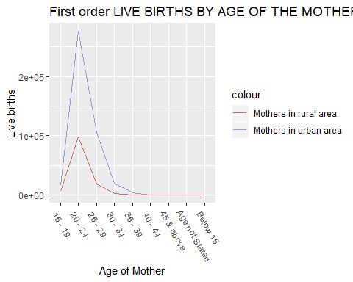

ggplot(data14_2, aes(x = Age.of.Mother, y = X1)) +  
 geom_boxplot() +  
 labs(title = "Mother's age vs. First Order Birth")

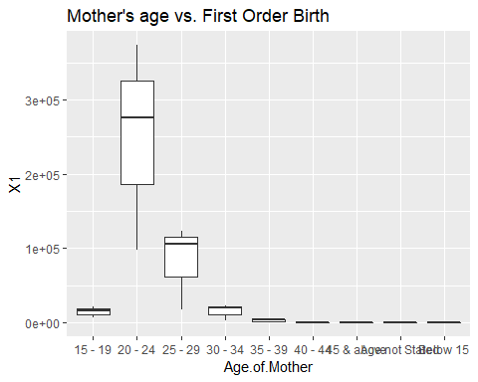

data14_3 <- read.csv("D:\\Vishal\\III year\\Data Analytics\\Assignment I\\data14.csv", skip = 95, header = TRUE, nrows = 18)  
  
head(data14_3)

## Level.of.Education.of.Father BO1 BO2 BO3 BO4 BO5 BO6 BO7 BO8  
## 1 Illiterate 5501 2083 10647 4520 1361 286 133 30  
## 2 Below Primary 13739 14839 7634 3667 629 153 49 16  
## 3 Primary but Below Matric 172400 140671 40999 3511 874 59 0 0  
## 4 Matric but Below graduate 237216 185546 39597 675 277 0 0 0  
## 5 Graduate & Above 117010 77234 5555 0 0 0 0 0  
## 6 Not Stated 65 56 59 0 276 82 23 15  
## BO9 BO10 BO11 BO12 BO13...Above Not.Stated Area  
## 1 18 6 1 0 0 0 All  
## 2 7 0 0 0 0 0 All  
## 3 0 0 0 0 0 0 All  
## 4 0 0 0 0 0 0 All  
## 5 0 0 0 0 0 0 All  
## 6 11 0 0 0 0 0 All

data14_3_filter <- data14_3 %>%  
 filter(Area != "All")  
  
p31 <- ggplot(data14_3_filter, aes(x = Level.of.Education.of.Father, y = BO1)) +  
 geom_bar(aes(fill = Area), stat="identity", position ="dodge") +   
 theme_bw()+   
 theme(axis.text.x = element_text(angle=-60, hjust=.1)) +  
 xlab("Education") + ylab("No. of people") +  
 labs(title = "LIVE BIRTHS BY LEVEL OF EDUCATION OF THE FATHER & BIRTH ORDER")  
  
p31

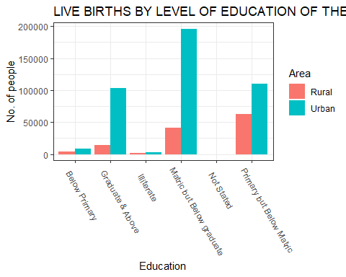

data15.r

Vishal

Sun Feb 17 11:09:16 2019

library(dplyr)

##   
## Attaching package: 'dplyr'

## The following objects are masked from 'package:stats':  
##   
## filter, lag

## The following objects are masked from 'package:base':  
##   
## intersect, setdiff, setequal, union

library(ggplot2)  
library(reshape2)  
  
data15 <- read.csv("D:\\Vishal\\III year\\Data Analytics\\Assignment I\\data15.csv", nrows = 30)  
data15 <- Filter(function(x)!all(is.na(x)), data15)  
tail(data15)

## District RegisteredBirth BirthRate RegisteredDeath DeathRate  
## 25 RAMANAGAR 8154 13.96 1719 5.50  
## 26 SHIMOGA 30719 13.55 6562 5.98  
## 27 TUMKUR 31416 14.46 6011 5.92  
## 28 UDUPI 14907 13.33 3823 3.96  
## 29 UTTARA KANNADA 24387 20.41 3281 4.79  
## 30 YADGIR 8417 22.18 1750 5.13  
## RegisteredInfantDeath RegisteredStillBirth StillBirthRate  
## 25 28 11 0.24  
## 26 549 269 4.55  
## 27 327 44 0.75  
## 28 234 108 2.73  
## 29 652 127 4.52  
## 30 52 0 0.00

col <- data15 %>%  
 select(RegisteredBirth, BirthRate, RegisteredDeath, DeathRate, RegisteredInfantDeath,  
 RegisteredStillBirth, StillBirthRate)  
  
d <- colnames(col)  
  
ggplot(data15, aes(x = District)) +  
 geom_bar(aes(y = RegisteredBirth), stat="identity", position ="dodge") +   
 theme_bw()+   
 theme(axis.text.x = element_text(angle=-60, hjust=.1)) +  
 labs(title = "Registered Births by district")

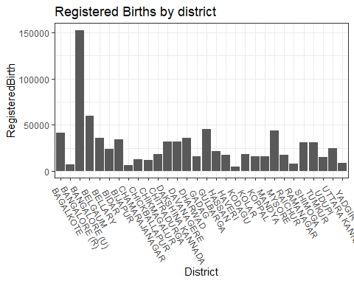

cor(data15$BirthRate, data15$DeathRate)

## [1] -0.00997159

ggplot(data15, aes(x = District)) +  
 geom_bar(aes(y = RegisteredInfantDeath), stat="identity", position ="dodge") +   
 theme_bw()+   
 theme(axis.text.x = element_text(angle=-60, hjust=.1)) +  
 labs(title = "Registered Infant Death by district")

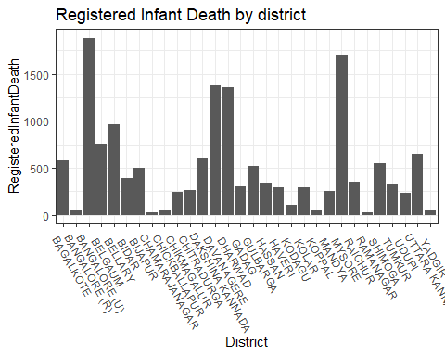

data15_2 <- read.csv("D:\\Vishal\\III year\\Data Analytics\\Assignment I\\data15.csv", skip = 36, nrows = 60)  
  
head(data15_2)

## District Sex Jan Feb Mar Apr May Jun Jul Aug Sep Oct Nov  
## 1 BAGALKOTE M 2003 1911 2101 1986 2110 1916 2407 2249 2124 2097 2304  
## 2 BAGALKOTE F 1892 1789 1877 1749 1934 1716 2050 1927 1832 2103 1974  
## 3 BANGALORE (R) M 475 481 384 582 369 336 432 406 308 395 302  
## 4 BANGALORE (R) F 351 383 440 539 319 344 303 338 273 422 266  
## 5 BANGALORE (U) M 7070 6345 7520 6531 7029 6744 6928 6858 6996 6491 6778  
## 6 BANGALORE (U) F 6429 5894 7011 6080 6705 6463 6458 6128 6534 6123 6413  
## Dec Total  
## 1 2532 25740  
## 2 2268 23111  
## 3 274 4744  
## 4 243 4221  
## 5 7090 82380  
## 6 6654 76892

p1 <- ggplot(data15_2, aes(x = District, y = Jan)) +  
 geom_bar(aes(fill = Sex), stat="identity", position ="dodge") +   
 theme_bw()+   
 theme(axis.text.x = element_text(angle=-60, hjust = .1))  
p1

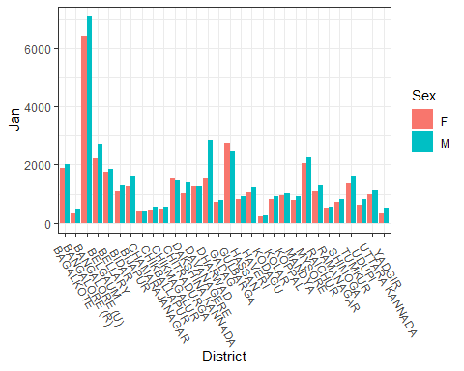

data15_3 <- read.csv("D:\\Vishal\\III year\\Data Analytics\\Assignment I\\data15.csv", skip = 108, nrows = 6, header = TRUE)  
  
data15_3 <- Filter(function(x)! all(is.na(x)), data15_3)  
  
melted <- melt(data15_3, Institution = c("Institution", "Area"))

## Using Institution, Area as id variables

ggplot(melted, aes(x = Institution, y = value, group = 1, label = value)) +  
 geom_bar(aes(fill = Area), stat = "identity") +  
 facet_wrap(~variable, scales = "free") +  
 geom_text(size = 3, position = position_stack(vjust = 0.5)) +  
 ylab("Number of cases") + xlab("Institutuion Type") +  
 labs(title = "Birth types")

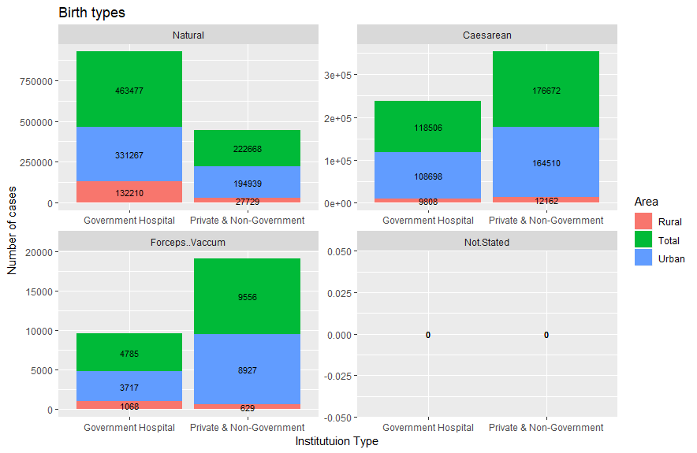

data2016.r

Vishal

Sun Feb 17 11:11:30 2019

library(dplyr)

##   
## Attaching package: 'dplyr'

## The following objects are masked from 'package:stats':  
##   
## filter, lag

## The following objects are masked from 'package:base':  
##   
## intersect, setdiff, setequal, union

library(ggplot2)  
library(reshape2)  
  
data16 <- read.csv("D:\\Vishal\\III year\\Data Analytics\\Assignment I\\data16.csv", nrows = 60)  
  
tail(data16)

## District Sex Jan Feb Mar Apr May Jun Jul Aug Sep Oct  
## 55 UDUPI M 765 858 990 867 976 762 772 855 807 847  
## 56 UDUPI F 716 788 843 773 893 678 649 801 713 756  
## 57 UTTARA KANNADA M 1072 1119 1333 1168 1235 1164 1132 1105 1090 1008  
## 58 UTTARA KANNADA F 907 953 1198 973 1149 1061 1034 976 1010 971  
## 59 YADGIR M 1420 1003 1212 1038 1081 1137 1082 1163 1071 1022  
## 60 YADGIR F 1267 929 1106 1005 1012 1028 1050 1052 896 934  
## Nov Dec X X.1  
## 55 887 803 NA NA  
## 56 808 749 NA NA  
## 57 1164 1042 NA NA  
## 58 1098 974 NA NA  
## 59 1174 1079 NA NA  
## 60 1120 991 NA NA

melted <- melt(data16, Months = c("Jan", "Feb", "Mar", "Apr", "May", "Jun", "Jul",   
 "Aug", "Sep", "Oct", "Nov", "Dec"))

## Using District, Sex, X, X.1 as id variables

ggplot(melted, aes(x = District, y = value, group = 1, label = value)) +  
 geom_bar(aes(fill = variable), stat = "identity") +  
 facet_wrap(~Sex, scales = "free") +  
 geom_text(size = 2, position = position_stack(vjust = 0.5)) +  
 theme(axis.text.x = element_text(angle = 90, hjust = 1)) +  
 labs(title = "LIVE BIRTHS BY SEX AND MONTH OF OCCURRENCE - 2016") +  
 ylab("Live births")

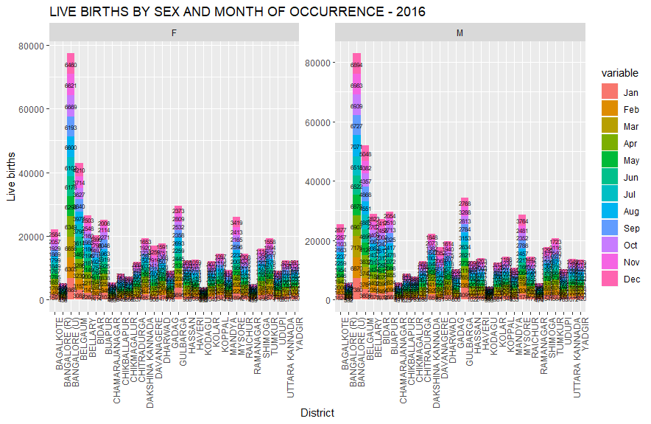

data16_2 <- read.csv("D:\\Vishal\\III year\\Data Analytics\\Assignment I\\data16.csv", skip = 64, nrows = 6)  
  
data16_2 <- Filter(function(x)! all(is.na(x)), data16_2)  
  
melted <- melt(data16_2, Institution = c("Institution", "Area"))

## Using Institution, Area as id variables

ggplot(melted, aes(x = Institution, y = value, group = 1, label = value)) +  
 geom_bar(aes(fill = Area), stat = "identity") +  
 facet_wrap(~variable, scales = "free") +  
 geom_text(size = 3, position = position_stack(vjust = 0.5)) +  
 ylab("Number of cases") + xlab("Institutuion Type") +  
 labs(title = "Birth types(2016)")

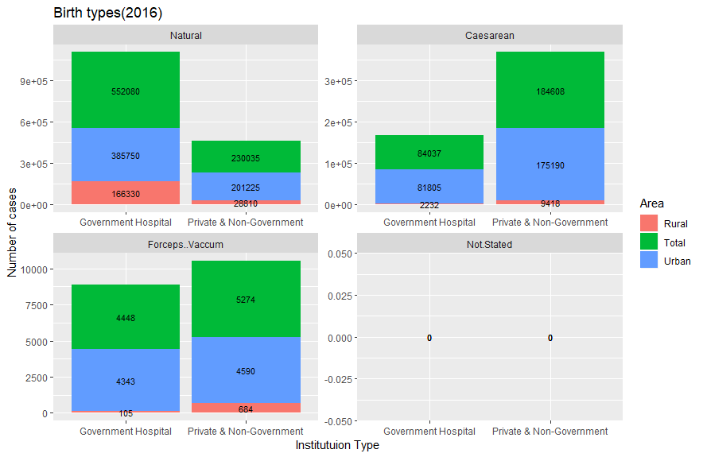

data16_3 <- read.csv("D:\\Vishal\\III year\\Data Analytics\\Assignment I\\data16.csv", skip = 73, nrows = 18)  
data16_3 <- Filter(function(x)! all(is.na(x)), data16_3)  
  
melted1 <- melt(data16_3, BirtOrder = c("EducationLevelFather", "Area"))

## Using EducationLevelFather, Area as id variables

ggplot(melted1, aes(x = EducationLevelFather, y = value, label = value)) +  
 geom_bar(aes(fill = Area), stat = "identity", position = "dodge") +  
 facet_wrap(~variable, scale = "free") +  
 theme(axis.text.x = element_text(angle = 20, hjust = 1)) +  
 labs(title = "LIVE BIRTHS BY LEVEL OF EDUCATION OF THE FATHER & BIRTH ORDER  
(RURAL & URBAN) - 2016")

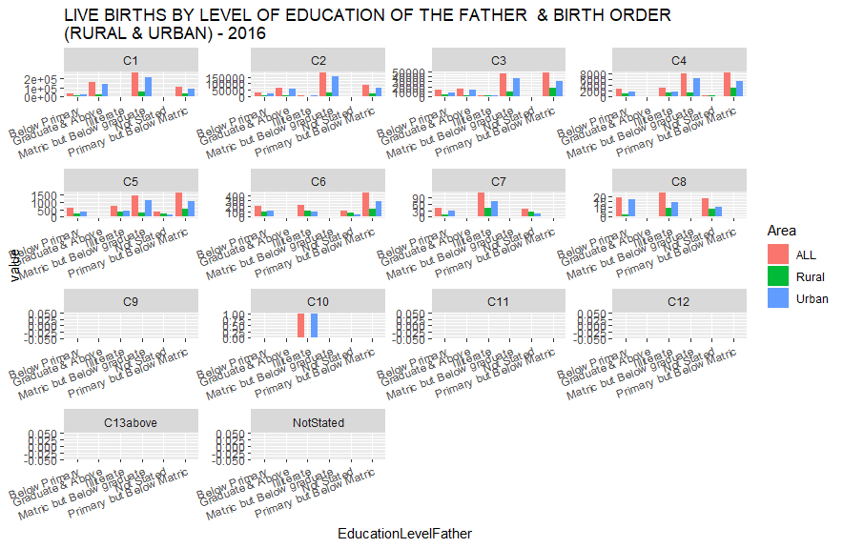

AllYears.r

Vishal

Sun Feb 17 11:14:00 2019

library(dplyr)

##   
## Attaching package: 'dplyr'

## The following objects are masked from 'package:stats':  
##   
## filter, lag

## The following objects are masked from 'package:base':  
##   
## intersect, setdiff, setequal, union

library(ggplot2)  
library(reshape2)  
library(ggpubr)

## Loading required package: magrittr

dataAll <- read.csv("D:\\Vishal\\III year\\Data Analytics\\Assignment I\\AllYears.csv")  
  
tail(dataAll)

## MethodofDelivery Below.15 X15.19 X20.24 X25.29 X30.34 X35.39 X40.44  
## 43 Forceps/Vacuum 0 367 3810 3249 1235 276 17  
## 44 Not Stated 0 0 0 0 0 0 0  
## 45 Natural 0 5965 132733 68831 8515 1532 226  
## 46 Caesarean 0 345 6087 3765 1166 267 19  
## 47 Forceps/Vacuum 0 51 432 239 53 11 3  
## 48 Not Stated 0 0 0 0 0 0 0  
## X45...Above Not.Stated Area Year  
## 43 2 0 Urban 2016  
## 44 0 0 Urban 2016  
## 45 99 0 Rural 2016  
## 46 1 0 Rural 2016  
## 47 0 0 Rural 2016  
## 48 0 0 Rural 2016

meltedData <- melt(dataAll)

## Using MethodofDelivery, Area as id variables

filter11 <- dataAll %>%  
 filter(Year == 2011)  
  
filter14 <- dataAll %>%  
 filter(Year == 2014)  
  
filter15 <- dataAll %>%  
 filter(Year == 2015)  
  
filter16 <- dataAll %>%  
 filter(Year == 2016)  
  
melt11 <- melt(filter11)

## Using MethodofDelivery, Area as id variables

melt14 <- melt(filter14)

## Using MethodofDelivery, Area as id variables

melt15 <- melt(filter15)

## Using MethodofDelivery, Area as id variables

melt16 <- melt(filter16)

## Using MethodofDelivery, Area as id variables

melt11_f <- melt11 %>%  
 filter(value != 2011)   
  
melt14_f <- melt14 %>%  
 filter(value != 2014)  
  
melt15_f <- melt15 %>%  
 filter(value != 2015)  
  
melt16_f <- melt16 %>%  
 filter(value != 2016)  
  
y1 <- ggplot(melt11_f, aes(x = MethodofDelivery, y = value, label = value)) +  
 geom_bar(aes(fill = variable), stat = "identity")+  
 facet_wrap(~Area) +  
 theme(axis.text.x = element_text(angle = 60, hjust = 1)) +  
 labs(title = "LIVE BIRTHS BY AGE OF MOTHER AND METHOD OF DELIVERY (RURAL & URBAN) - 2011")  
  
y2 <- ggplot(melt14_f, aes(x = MethodofDelivery, y = value, label = value)) +  
 geom_bar(aes(fill = variable), stat = "identity")+  
 facet_wrap(~Area) +  
 theme(axis.text.x = element_text(angle = 60, hjust = 1)) +  
 labs(title = "LIVE BIRTHS BY AGE OF MOTHER AND METHOD OF DELIVERY (RURAL & URBAN) - 2014")  
  
y3 <- ggplot(melt15_f, aes(x = MethodofDelivery, y = value, label = value)) +  
 geom_bar(aes(fill = variable), stat = "identity")+  
 facet_wrap(~Area) +  
 theme(axis.text.x = element_text(angle = 60, hjust = 1)) +  
 labs(title = "LIVE BIRTHS BY AGE OF MOTHER AND METHOD OF DELIVERY (RURAL & URBAN) - 2015")  
  
y4 <- ggplot(melt16_f, aes(x = MethodofDelivery, y = value, label = value)) +  
 geom_bar(aes(fill = variable), stat = "identity")+  
 facet_wrap(~Area) +  
 theme(axis.text.x = element_text(angle = 60, hjust = 1)) +  
 labs(title = "LIVE BIRTHS BY AGE OF MOTHER AND METHOD OF DELIVERY (RURAL & URBAN) - 2016")  
  
  
ggarrange(y1, y2, y3, y4,   
 labels = c("2011", "2014", "2015", "2016"),  
 ncol = 2, nrow = 2)

